Merry Christmas
Find the words and match the pictures
F | C | T | G | R | M | E | L | F | P | Q | H | G | H | U
C | A | N | G | E | L | R | T | E | D | K | O | J | L | Y
V | N | T | B | R | T | G | A | E | B | E | L | L | M | E
J | D | I | H | U | T | R | C | S | S | D | L | F | T | J
Y | Y | R | T | E | H | O | D | F | W | Q | Y | N | H | D
S | C | K | Y | S | R | E | I | N | D | E | E | R | H | B
E | A | Y | T | A | F | C | D | M | G | S | Y | U | S | G
A | N | D | T | H | D | J | H | H | E | S | A | N | T | A
T | E | I | D | B | G | H | D | R | J | F | G | K | T | N
T | O | Y | G | H | O | D | P | L | I | G | H | T | S | A
N | A | Y | K | F | H | W | T | S | O | S | I | D | M | M
A | T | F | S | L | E | I | G | H | F | A | T | F | N | W
H | T | A | H | C | J | T | S | U | T | R | S | M | F | O
D | F | G | A | V | J | Y | A | R | E | A | A | K | A | N
S | T | O | C | K | I | N | G | E | Y | D | K | J | F | S
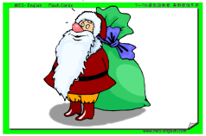
STOCKING
CANDYCANE
FATHER CHRISTMAS
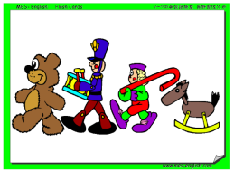
SLEIGH
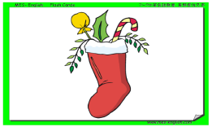
REINDEER
ANGEL
BELL
PRESENT
TREE
SNOWMAN
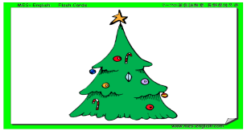
TOYS
DECORATION
ELF
HOLLY
LIGHTS

