**1.** Выберите фотографию и опишите человека на ней. У вас есть полторы минуты на подготовку и не более двух минут для ответа. У вас должен получиться связный рассказ (7–8 предложений).

План ответа поможет вам:

— the place

— the action

— the appearance of the person

— whether you like the picture or not

— why

Start with: **“I’d like to describe picture № ... . The picture shows …”**

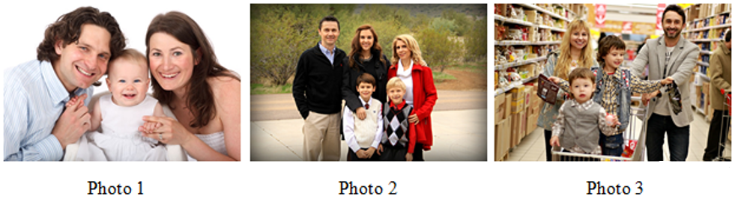

I’d like to describe picture № 1. The picture shows us a family.

The photo was (probably) taken inside.

In this picture the action is taking place in the room. Looking at this family I get the impression that they are smiling at the camera. The girl`s parents look like they are in their early thirties.

They are wearing fancy clothes. The girl looks like she is about 2 years old. I guess she is quiet and kind, because she has a beautiful smile.

I like the picture because the atmosphere is peaceful.

It makes me think of my family.