**3.** Выберите фотографию и опишите человека на ней. У вас есть полторы минуты на подготовку и не более двух минут для ответа. У вас должен получиться связный рассказ (7–8 предложений).

План ответа поможет вам:

— the place

— the action

— the appearance of the person

— whether you like the picture or not

— why

Start with: **“I’d like to describe picture № ... . The picture shows …”**

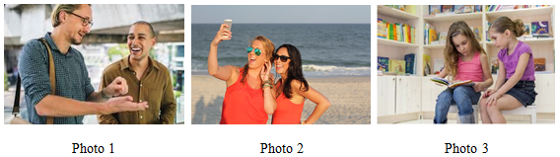

I’d like to describe picture № 3. The picture shows us a couple of friends.

The photo was (probably) taken inside. In this picture the action is taking place in the room.

I think that we can see two friends. Looking at this picture I get the impression that they are reading a book. One girl is holding the book and shows something to her friend.

Both girls are wearing casual clothes. They look like they are about 9 years old. I guess they are quiet and kind, because they have kind smiles.

I like the picture because the atmosphere is peaceful.

It makes me think of my childhood.