**Описание фото**

|  |  |
| --- | --- |
| **Introduction** | I’d like to describe picture № ... . The picture shows us … *(a young girl / boy, a man / a woman, a couple of friends, a family etc.)* |
| 1. **The place** | - It was (probably) taken *inside / outside*. |
| - In this picture the action is taking place in (*the house, the living room, the gym, the swimming pool, the theme park etc.).* |
| 1. **The action** | * Looking at *these people / this girl / this boy* I get the impression that *they are* / *she is / he is* ........ *(having dinner; watching a film; doing their homework etc.)* |
| * The man is …*smil*ing*.* |
| * The people are *…work*ing*.* |
| * It’s *rain*ing*.* It’s sunny. |
| 1. **The appearance of the person** | The *girl / boy* looks like *he / she* is about … years old. |
| *She / he* has … eyes and *dark / fair* hair |
| The *girl / boy* is wearing … |
| I guess *she / he* is quiet and kind. |
| 1. **Whether you like the picture or not** | I like the picture because the atmosphere is *peaceful* / *full of positive emotions*. |
| 1. **Why** | It makes me think of *my friends, my sister, my family, summer/winter/autumn/ spring.*  It reminds me of my *visit to*… |

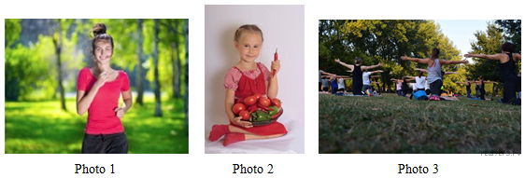

|  |  |
| --- | --- |
| **Introduction** | **I’d like to describe picture №** 1. **The picture shows us** a young girl. |
| **1. The place** | **The photo was (probably) taken** outside. |
| **In this picture the action is taking place in the** park. |
| **2. The action** | * **Looking at this picture I get the impression that** the girl is jogging. She is running to the photographer. |
| **3. The appearance of the person** | **She is wearing** sportswear. **She looks like she is** about 16 years old.  **I guess she is** cheerful and kind, because she has a beautiful smile. |
| **4. Whether you like the picture or not** | **I like the picture because the atmosphere is peaceful and full of positive emotions.** |
| **5. Why** | **It makes me think of** my sister. |