**2.** Выберите фотографию и опишите человека на ней. У вас есть полторы минуты на подготовку и не более двух минут для ответа. У вас должен получиться связный рассказ (7–8 предложений).

План ответа поможет вам:

— the place

— the action

— the appearance of the person

— whether you like the picture or not

— why

Start with: **“I’d like to describe picture № ... . The picture shows …”**

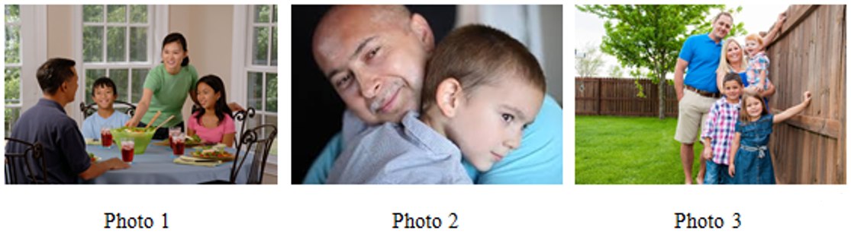

I’d like to describe picture № 2. The picture shows us a family.

The photo was (probably) taken inside. In this picture the action is taking place in the room.

I think that we can see a father and a son. Looking at this family I get the impression that they are smiling and hugging. The parent looks like he is in his mid-thirties.

Both the father and the son are wearing fancy clothes. The boy looks like he is about 8 years old. I guess he is quiet and kind, because she has a kind smile.

I like the picture because the atmosphere is peaceful.

It makes me think of my family.