**11.** Выберите фотографию и опишите человека на ней. У вас есть полторы минуты на подготовку и не более двух минут для ответа. У вас должен получиться связный рассказ (7–8 предложений).

План ответа поможет вам:

— the place

— the action

— the appearance of the person

— whether you like the picture or not

— why

Start with: **“I’d like to describe picture № ... . The picture shows …”**

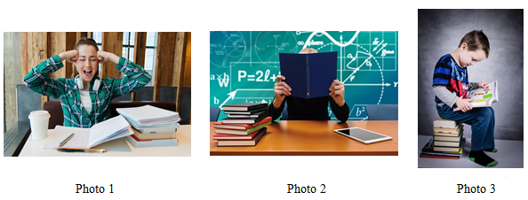

I’d like to describe picture № 2. The picture shows us a classroom and a teacher.

The photo was (probably) taken inside. In this picture the action is taking place in the classroom.

Looking at this picture I get the impression that the teacher is very busy and doesn`t have time to for taking photographs. This teacher is not showing the face, so we can see only an opened book.

This person is wearing beautiful smart clothes. I guess that the teacher is hardworking, serious and successful.

I like the picture because the atmosphere is busy.

It makes me think of my class and our teacher.