|  |  |  |  |
| --- | --- | --- | --- |
|  | **Teacher’s name** | Belokopytova Alya Ravilevna and Sultanova Aigul Shagitovna | |
|  | **School** | School № 9 | |
|  | **City** | Noyabrsk | |
|  | **Literature** | Student’s book: Spotlight 7. Module 3b. Who’s who? | |
|  | **Name and/or type of the activity** | Role-play | |
|  | **Language level** | Pre-Intermediate to Upper-Int | |
|  | **Time** | 40 min | |
|  | **Objective** | By the end of the activity pupil must describe his / her favorite character in a book. | |
|  | **Target language (Grammar/ Vocabulary)** | Target grammar: general questions, present continuous, verb” to be”, “to have”.  Target vocabulary: appearance, clothes. | |
|  | **Preparation and Materials** | If online:  PPT slides or pdf files with role-play cards for students | |
|
|  | **Step-by-step procedure**  **WC- whole class**  **GW – group work**  **PW – pair work**  **IW - individually)** | **Steps** | **Timing and interaction pattern** |
| We put chairs in a circle, there are fewer chairs than participants. The teacher calls various words on this topic "appearance", children go around the chairs in a circle,as soon as they name a word from another topic, children quickly take chairs. Who did not have time, that together with one chair leaves the circle.  Appendix 1. | 5 min, WC |
| Pair the students. 1. A game “Secret Agent”.  Find out the Secret Agent by asking questionsPick up one of these to see which one are you!Cross the one you know it can´t be!  2. Introduction: Ask students the following questions One pupil gets a picture of character and other asks general questions about appearance of this character?   * Has she got a long (curly/straight / fair) hair? * Is she short (tall / thin / fat)?   Appendix 2. | 1. min, PW |
| A game for practicing vocabulary 'Appearance”. The task is to find out the criminal.  Appendix 3 | 10 min, GW |
|  | Possible Follow-up | Write a short paragraph about your favorite character in a book. Write^ name, appearance, character, what is special about him/her. | 15 min. IW |

**Appendix 1.**

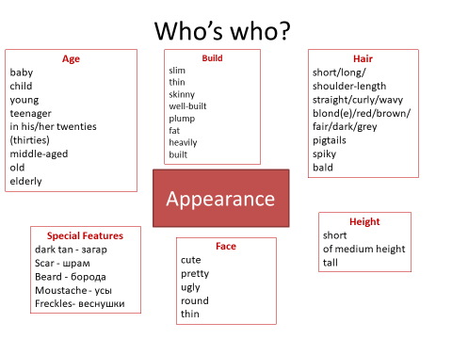

**Appendix 2 (1)**

|  |  |
| --- | --- |
| **Secret Agent** | |
| caras1 | caras2 |
| CARAS31 | CARAS32 |

|  |  |
| --- | --- |
| Verb “To be”:   * Are you a girl? * Are you a boy? * Are you old? * Are you young? * Are you from …….?   (country name)   * Are you number....? | Verb “to have”   * **Have you got** *red / white / black / blonde / brown* **hair?** * **Have you got** *blue / black / green* **eyes?** * Have you got glasses? * Have you got beard/moustache? * Have you got a mole? * Have you got a hat? |
| **Yes, I am**  **No, I am not** | **Yes, I have**  **No I haven’t** |

**Find out the Secret Agent by asking questions**

**Pick up one of these to see which one are you!**

|  |  |  |  |  |  |
| --- | --- | --- | --- | --- | --- |
| One | Two | Three | Four | Five | Six |
| Seven | Eight | Nine | Ten | Eleven | Twelve |
| Thirteen | Fourteen | Fifteen | Sixteen | Seventeen | Eighteen |
| Nineteen | Twenty | Twenty one | Twenty two | Twenty three | Twenty four |

**Cross the one you know it can´t be!**

Clue charts:

|  |  |  |  |  |  |
| --- | --- | --- | --- | --- | --- |
| 1 | 2 | 3 | 4 | 5 | 6 |
| 7 | 8 | 9 | 10 | 11 | 12 |
| 13 | 14 | 15 | 16 | 17 | 18 |
| 19 | 20 | 21 | 22 | 23 | 24 |

**Appendix 2 (2)**

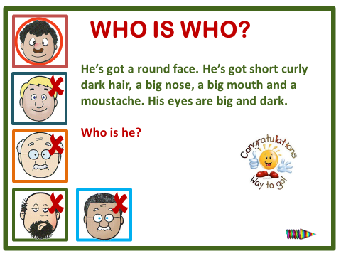

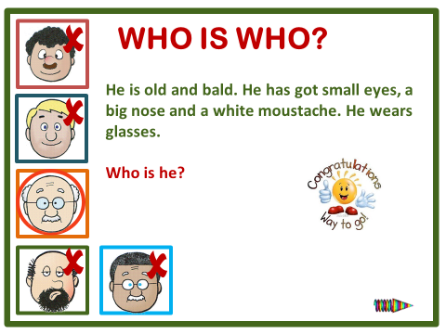

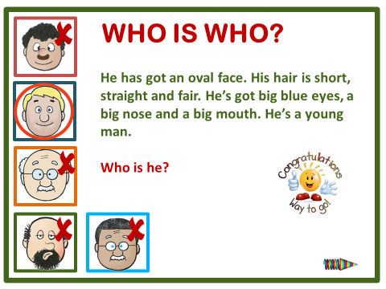

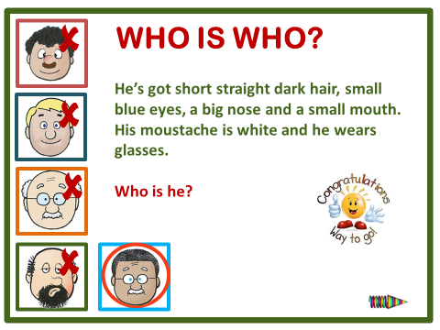

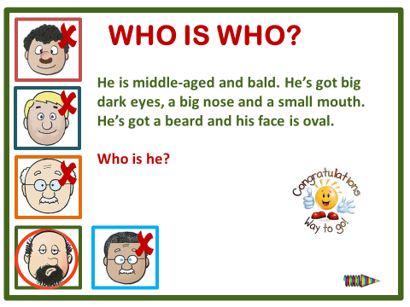

**Appendix 3.**

