**12.** Выберите фотографию и опишите человека на ней. У вас есть полторы минуты на подготовку и не более двух минут для ответа. У вас должен получиться связный рассказ (7–8 предложений).

План ответа поможет вам:

— the place

— the action

— the appearance of the person

— whether you like the picture or not

— why

Start with: **“I’d like to describe picture № ... . The picture shows …”**

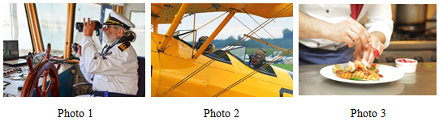

I’d like to describe picture № 2. The picture shows us a pilot gear.

The photo was (probably) taken outside. In this picture the action is taking place on the airfield.

Looking at this picture I get the impression that they are discussing something important.

They are wearing uniform. An airplane is bright yellow, that it is eye catching. Both men look like they are in their early forties. I guess they are ambitious and competitive, because they look very determined.

I like the picture because the atmosphere is enthusiastic.

It makes me think of my uncle.