**8.** Выберите фотографию и опишите человека на ней. У вас есть полторы минуты на подготовку и не более двух минут для ответа. У вас должен получиться связный рассказ (7–8 предложений).

План ответа поможет вам:

— the place

— the action

— the appearance of the person

— whether you like the picture or not

— why

Start with: **“I’d like to describe picture № ... . The picture shows …”**

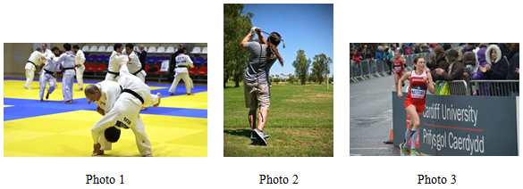

I’d like to describe picture № 1. The picture shows us a martial arts tournament.

The photo was (probably) taken inside. In this picture the action is taking place in the sports hall.

Looking at this picture I get the impression that they are fighting.

They are wearing kimonos. They look like they are in their early forties. I guess they are ambitious and competitive, because they look very determined.

I like the picture because the atmosphere is enthusiastic.

It makes me think of my brother.