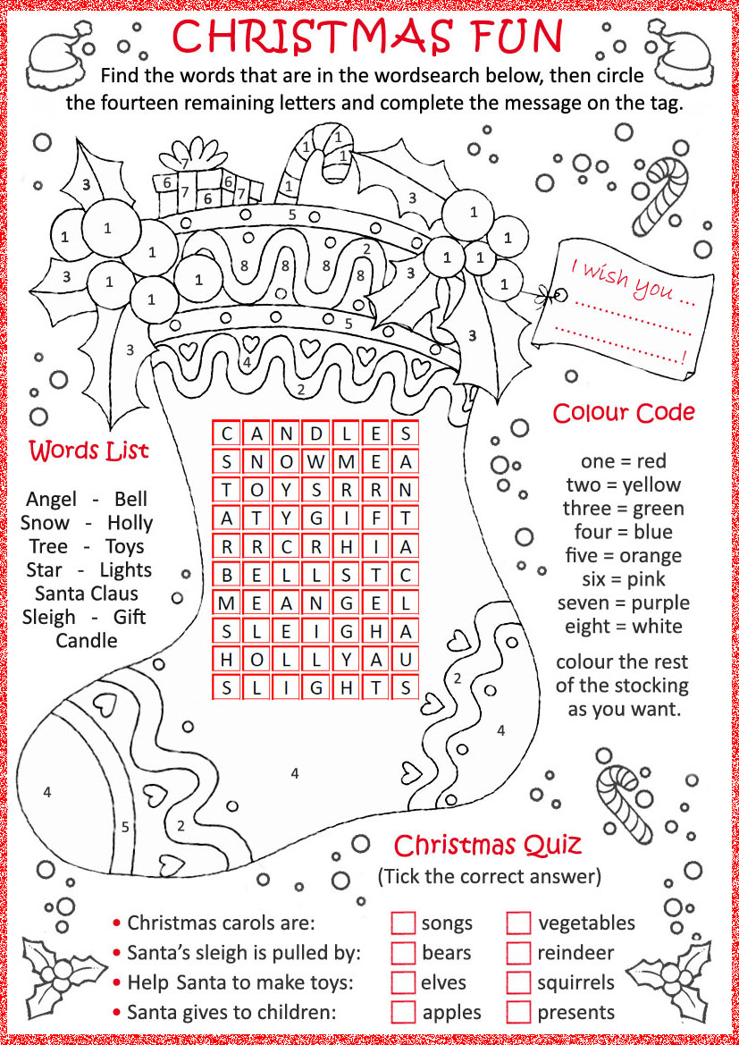

KEY

|  |  |  |  |  |  |  |
| --- | --- | --- | --- | --- | --- | --- |
| C | A | N | D | L | E | S |
| S | N | O | W | M | E | A |
| T | O | Y | S | R | R | N |
| A | T | Y | G | I | F | T |
| R | R | C | R | H | I | A |
| B | E | L | L | S | T | C |
| M | E | A | N | G | E | L |
| S | L | E | I | G | H | A |
| H | O | L | L | Y | A | U |
| S | L | I | G | H | T | D:\christmas\navid1.gifS |



Message on the tag:

I wish you…

**MERRY CHRISTMAS!**

Christmas Quiz

• Christmas carols are: songs

• Santa’s sleigh is pulled by: reindeer • Help Santa to make toys: elves• Santa gives to children: presents