**5.** Выберите фотографию и опишите человека на ней. У вас есть полторы минуты на подготовку и не более двух минут для ответа. У вас должен получиться связный рассказ (7–8 предложений).

План ответа поможет вам:

— the place

— the action

— the appearance of the person

— whether you like the picture or not

— why

Start with: **“I’d like to describe picture № ... . The picture shows …”**

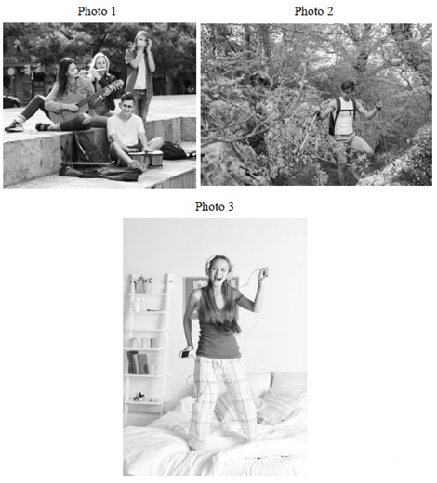

I’d like to describe picture № 3. The picture shows us a girl.

The photo was (probably) taken inside. In this picture the action is taking place in the room.

Looking at this picture I get the impression that she is listening to her favorite song. The girl is holding her smartphone. She is jumping on the bed and probably tries to dance to the tune.

The girl is wearing pajamas. She looks like she is about 15 years old. I guess she is cheerful and happy, because she has a beautiful smile.

I like the picture because the atmosphere is peaceful.

It makes me think of my free time and my favorite music.