**10.** Выберите фотографию и опишите человека на ней. У вас есть полторы минуты на подготовку и не более двух минут для ответа. У вас должен получиться связный рассказ (7–8 предложений).

План ответа поможет вам:

— the place

— the action

— the appearance of the person

— whether you like the picture or not

— why

Start with: **“I’d like to describe picture № ... . The picture shows …”**

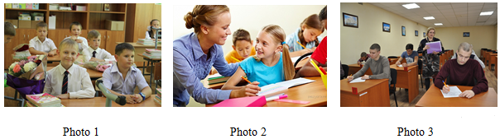

I’d like to describe picture № 2. The picture shows us a class and their teacher.

The photo was (probably) taken inside. In this picture the action is taking place in the classroom.

Looking at this picture I get the impression that they are completing an interesting task. The girl is looking at the teacher.

The girl is wearing casual bright clothes. The teacher is wearing beautiful smart clothes. The looks like she is about 12 years old. The teacher looks like she is in her late twenties. I guess she is cheerful and kind, because she has a beautiful smile.

I like the picture because the atmosphere is peaceful.

It makes me think of my class and our teacher.