**6.** Выберите фотографию и опишите человека на ней. У вас есть полторы минуты на подготовку и не более двух минут для ответа. У вас должен получиться связный рассказ (7–8 предложений).

План ответа поможет вам:

— the place

— the action

— the appearance of the person

— whether you like the picture or not

— why

Start with: **“I’d like to describe picture № ... . The picture shows …”**

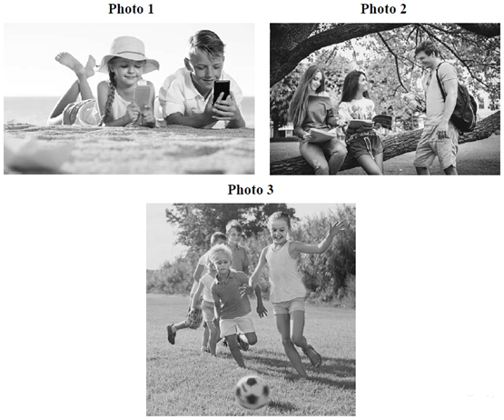

I’d like to describe picture № 3. The picture shows us a group of friends.

The photo was (probably) taken outside.

In this picture the action is taking place on the playground. Looking at this picture I get the impression that they are playing football. The girl is chasing the ball. She is running towards it and the boy is competing with her.

All children are wearing summer clothes. They look like they are about 10 years old. I guess they are cheerful and happy, because they have winning smiles.

I like the picture because the atmosphere is peaceful and cheerful at the same time.

It makes me think of summer.