**4.** Выберите фотографию и опишите человека на ней. У вас есть полторы минуты на подготовку и не более двух минут для ответа. У вас должен получиться связный рассказ (7–8 предложений).

План ответа поможет вам:

— the place

— the action

— the appearance of the person

— whether you like the picture or not

— why

Start with: **“I’d like to describe picture № ... . The picture shows …”**

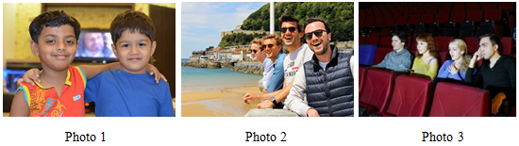

I’d like to describe picture № 3. The picture shows us a group of friends.

The photo was (probably) taken inside.

In this picture the action is taking place in the cinema. I think that we can see four friends. Looking at this picture I get the impression that they are watching a movie. One girl is holding her hands at her chest. It shows us that she is excited.

All friends are wearing casual clothes. They look like they are about 15 years old. I guess they are quiet and kind, because they have winning smiles.

I like the picture because the atmosphere is peaceful.

It makes me think of my friends.