**7.** Выберите фотографию и опишите человека на ней. У вас есть полторы минуты на подготовку и не более двух минут для ответа. У вас должен получиться связный рассказ (7–8 предложений).

План ответа поможет вам:

— the place

— the action

— the appearance of the person

— whether you like the picture or not

— why

Start with: **“I’d like to describe picture № ... . The picture shows …”**

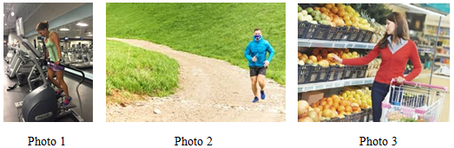

I’d like to describe picture № 1. The picture shows us a girl.

The photo was (probably) taken outside. In this picture the action is taking place in the park.

Looking at this picture I get the impression that she is jogging. The girl is running to the photographer.

She is wearing sportswear. She looks like she is about 16 years old. I guess she is cheerful and kind, because she has a beautiful smile.

I like the picture because the atmosphere is peaceful.

It makes me think of my sister.